**# Godot 2D Combat Player Controller**

A modular 2D player controller with movement, jump mechanics, dash, combos,

hurt/death states, and health system.

**## Features**

**- Idle, Run:**



**- Jump, Double Jump:**



**- Coyote Time & Jump Buffer:**



**- Ground & Air Dash:**



**- 3-Hit Combo System (Ground + Air):**



**- Hurt & Death States:**



**- HitBox / HurtBox Damage System:**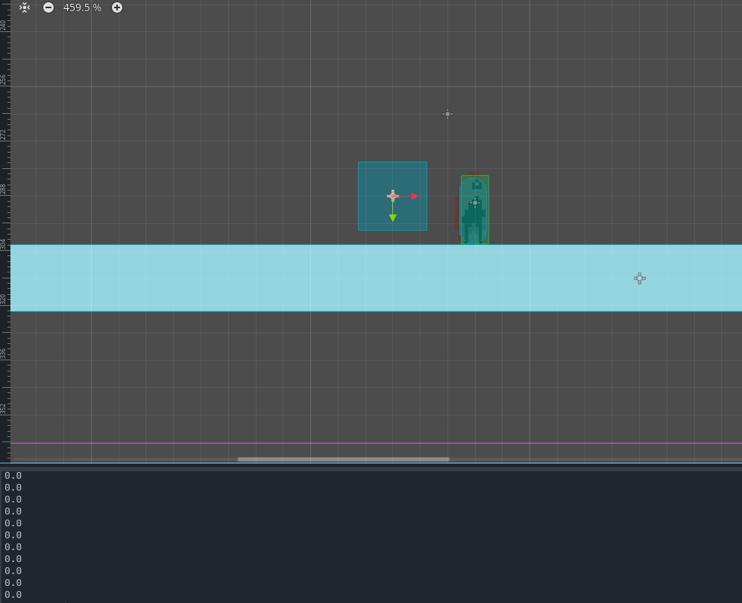

**Demo**

🎥 **YouTube Tutorial Playlist**  
<https://www.youtube.com/playlist?list=PLoi6vvfocDd7S-243oG-e6McVd4Yz4Iqv>

➤ The playlist explains all core mechanics used in this project.

🎮 A test scene is included in the project for quick testing.

## Requirements-

Godot 4.2+

**## Installation**

1. Download or clone this repository

2. Open the project in Godot

3. Open `Scenes/TestScene.tscn`

4. Press ▶ Play

**⚠️ Important:**

- Do not rename folders

- Do not remove AnimationPlayer

**## Project Structure**

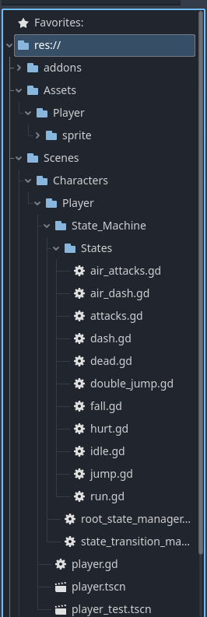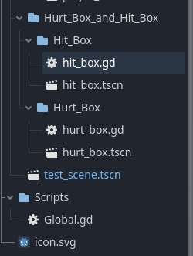

**Dependencies & Credits**

**Note:** All addons and sprites used in this project are free to use.

**### Plugin**

- **State Chart** – Available on the Godot Asset Library

(Search for **Godot State Charts**) 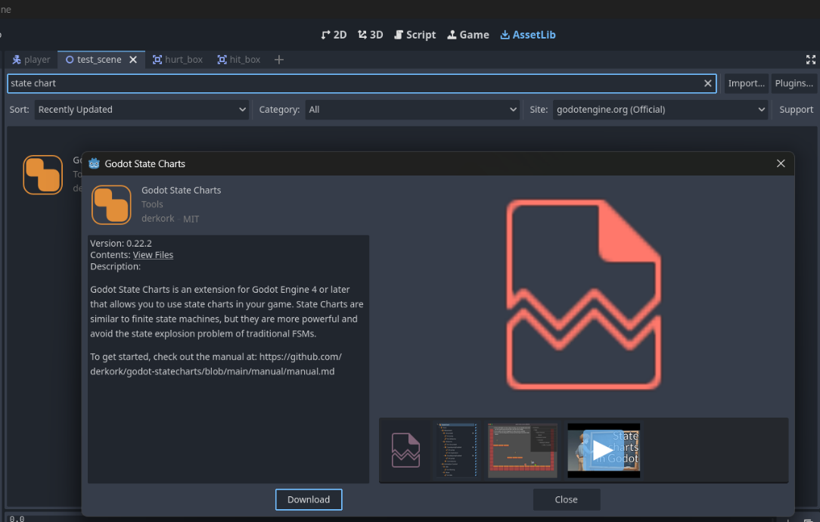

**### Sprites**

- 2D Action Platformer Sci-Fi Vagabond Pack

<https://pixramen.itch.io/2d-action-platformer-sci-fi-vagabond>

**## Scripts Overview**

**- **Player.gd\*\***

➤ The main parent script. It supervises all child scripts and provides shared

values and references to child nodes.

**- **Jump & Gravity Manager\*\***

➤ Handles all jump-related physics, including gravity, jump buffer, coyote time,

and variable jump height.

This system uses ground and air state signals, works independently, but depends

on the parent `Player.gd` for data.

**- **State Transition Script\*\***

➤ Manages transitions between states based on priority.

Example priority order:

Dash > Attack > Hurt > Death

**- **State Scripts\*\***

➤ Each state has its own script. These scripts are independent of each other and

handle only small, state-specific logic such as animations or behavior.

**- **HurtBox.gd\*\***

➤ Manages health and damage deduction when the player receives damage.

**- **HitBox.gd\*\***

➤ Responsible only for defining and applying the amount of damage dealt.

**- **Dash & Air Dash\*\***

➤ Dash and Air Dash share approximately 70% common logic and can be extended

using a shared base script.

**- **Attack & Air Attack\*\***

➤ Attack and Air Attack share approximately 80% common logic and are also

extendable using a shared base script.

**### Important Note**

- Air attacks and ground attacks should use **separate combo timers**.

This helps avoid future bugs and makes the system more stable.

- Combo windows and counter windows for both air and ground attacks

must be adjusted using the **AnimationPlayer**, based on the animations

you are using.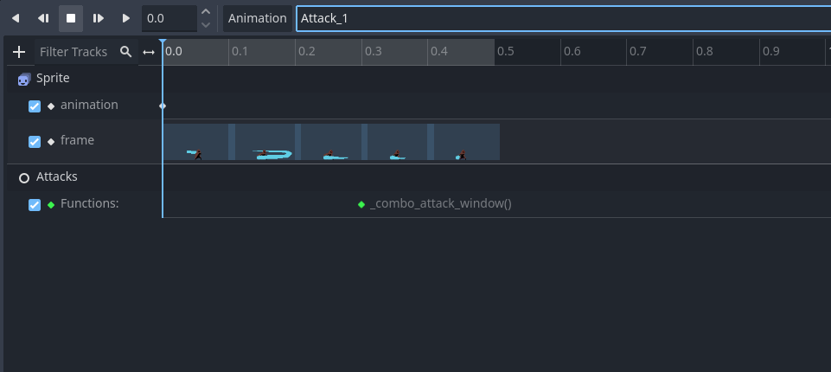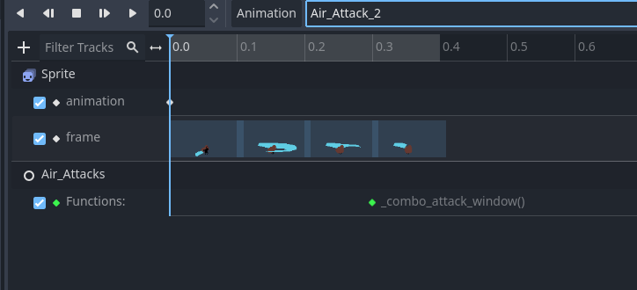

**## How to Use**

**### Before Adding New Animations:**

➤ Choose **one** of the following approaches based on your animation setup:

**#### Option 1: Same Number of Frames (Recommended):**

- If your animation has the **same number of frames** as the provided one,

simply replace the frames in the `AnimatedSprite`.

- The `AnimationPlayer` will update automatically.

- No additional changes are required.

**#### Option 2: Different Number of Frames:**

- If your animation has a **different number of frames**:

- Update both the `AnimatedSprite` **and** the `AnimationPlayer`.

- Add only the **extra frames** to the `AnimationPlayer`.

- Increase the animation length accordingly.

**\*\*Example:\*\***

If the original attack animation has 4 frames and yours has 5,

only the 5th frame needs to be added to the `AnimationPlayer`.

**#### Option 3: Custom Animation Setup:**

- Remove the existing `AnimatedSprite`.

- Recreate the animation fully from scratch using your own setup.

---

**### ⚠️ Important Notes**

**- **Do NOT rename animations.\*\***

Animation names are referenced directly in code.

Renaming them may cause *animation not found* errors or crashes.

- Always verify timing after replacing animations, especially for:

- Combo windows

- Counter windows

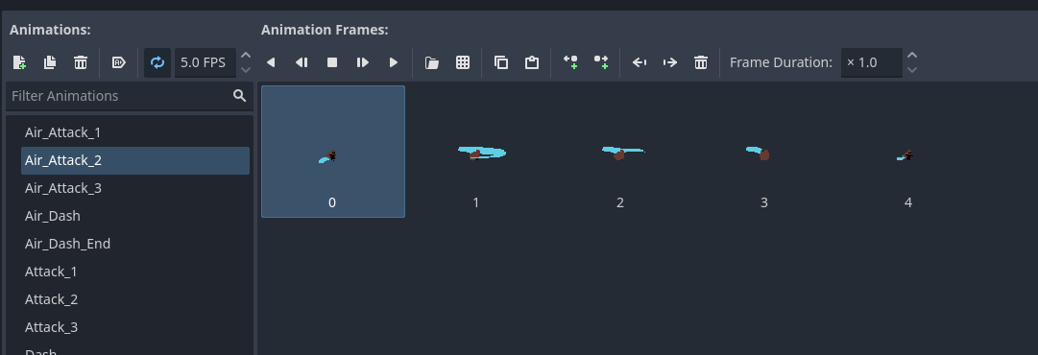

**### Adding Additional Combo Attacks:**

To add more combo attacks, you must extend the **State Chart** by adding a new

atomic state and connecting it correctly.

**#### Steps**

**1. **Add a New Atomic State\*\***

- In the State Chart, create a new atomic state for the new combo.

- Example: `Combo_4`

**2. **Create Transition From the Previous Combo\*\***

- Select the **last existing combo state** (e.g. `Combo_3`).

- Add a new transition from `Combo_3` to `Combo_4`.

- Set the transition condition to `next`.

**3. **Configure the New Combo State\*\***

- Select the newly added combo state (`Combo_4`).

- Connect the following signals:

- `state_entered` → plays the combo animation

- `state_exited` → connect to `_on_combo_state_exited`

- `state_physics_processing(delta)` → connect to

`_on_combo_state_physics_processing(delta)`

4. **\*\*Update Combo Window\*\***

- Add a combo window to the **second-last combo state**

(e.g. `Combo_3`).

- This allows the transition to the newly added combo (`Combo_4`).

Once these steps are completed, the new combo attack is ready to use.



> If you need a visual walkthrough, watch the full explanation in the

> YouTube tutorial playlist linked above.

**## License**

**MIT License**

**## Credits**

**Developed by Priyansh Singh**